Connecticut’s Only Screening
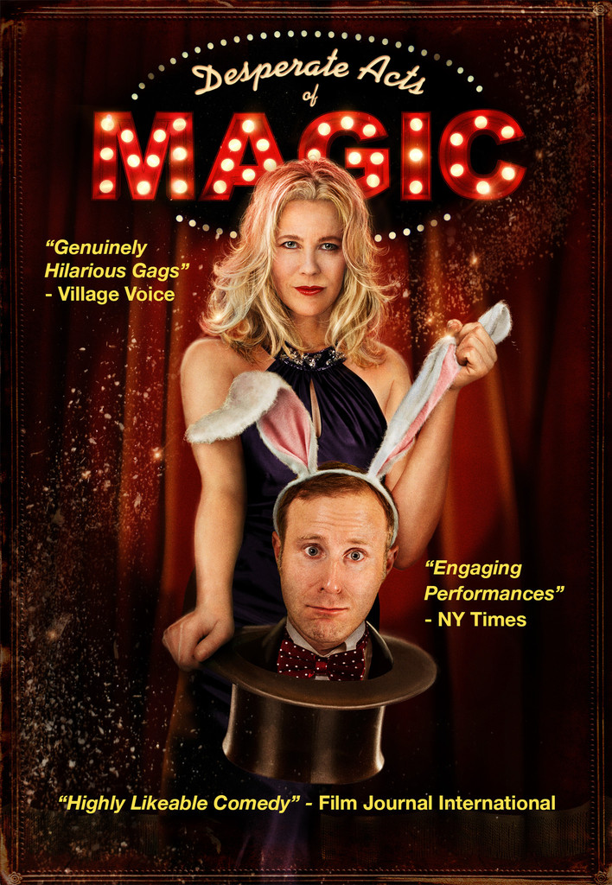

Monday November 2nd, 2013

Doors Open 7:00 pm
Showing 7:30 – 9:00 pm
SPECIAL SKYPE SESSION WITH FILM’S CREATOR 9:00 – 9:30 PM
Trumbull Public Library
33 Quality Street
Trumbull, CT

FREE POPCORN AND SNACKS!
Public showing sponsored by International Brotherhood of Magicians Ring 59
www.ibmring59.com cyril.may@aya.yale.edu 203-737-0475

